Nazarbayev Intellectual school of Science and Mathematics in Karagandy

QazaqSignAI:A game for learning sign language
Category: AI Programming

Students: Zhanabekova Naimuluna, Yekpin Zhanerke
Supervisor: Kirill Nabiyev

Karagandy, 2026

Contents

Abstract 3
Introduction 3
Objectives of the research 3
Hypothesis 4
Relevance of the Topic 4
Development stages 4
Methodology 4
Novelty of the research 5
Results and conclusions 5
Practical applications of the results 5
Theoretical Part 5
Practical Part 6
Methods for creating application 7
Collection of information 7
Analytical Review of Existing Sign Language Learning Tools 8
Implementation and analysis 10
Design of the application 12
Conclusion: 13

Abstract
QazaqSignAI is a project for the development of an AI-based educational game for the learning of Kazakh Sign Language through technology-based learning methods. This project focuses on the development of a learning platform for the learning of Kazakh Sign Language through the use of AI and gamification. This project has been developed using the Python programming language and the Pygame library for the development of the interface and the gamification of the learning platform. In addition, the Google MediaPipe Hand Landmarker has been used for the development of the hand-tracking module of the project. This module tracks the video feed of a webcam and detects the positions of the 21 key hand landmarks in three-dimensional space, with each landmark having x, y, and z coordinates. This information is then used by the AI module for the recognition of gestures and static and dynamic hand movements. In addition, the AI module has been designed for the recognition of hand gestures through the analysis of a sequence of 20 video frames, with the statistical features used for the analysis of the position of the fingers and the overall motion of the hand. The interface of the project has been designed with a thematic "quest" style, with the overall design inspired by the cultural traditions of the Kazak people. This project demonstrates the use of AI for the development of educational games for the learning of the Kazakh Sign Language.

Introduction

Objectives of the research
The primary objective of this research is to develop an educational game that facilitates the acquisition of Kazakh sign language through interactive gameplay. This initiative distinguishes itself by incorporating gesture recognition technology, enabling the application to visually interpret users’ signs and provide immediate responses. The project is structured around several key aims:
- Integrate machine learning algorithms to accurately identify user gestures and deliver instant evaluative feedback. This enables learners to receive timely assessments of their performance.
- Apply established principles of game mechanics—including progression levels, point systems, progress indicators, and reward structures—to enhance user engagement and motivation throughout the learning process.
- Evaluation with real users in authentic settings. The research team intends to quantitatively assess both the learning outcomes and the functional efficacy of the application through empirical data.

Hypothesis
Integration of gamification and real-time feedback mechanisms can significantly increase learner participation and effectiveness of sign language acquisition compared to traditional learning approaches.

Relevance of the Topic
For individuals who are Deaf or Hard-of-Hearing, sign language constitutes an essential mode of interaction. Nevertheless, the prevalence of sign language acquisition among the general population remains low, and traditional instructional methods—such as textbooks, written guides, and standard video lessons—often lack interactivity and adaptability, leading to diminished learner motivation and suboptimal progress (Willoughby & Sell, 2019). Contemporary learners increasingly seek interactive and experiential methods for skill acquisition, as evidenced by the widespread adoption of games, applications, and mobile platforms in education. However, existing tools for sign language learning are frequently characterised by rigidity, limited interactivity, and insufficient feedback mechanisms, resulting in low retention and engagement rates. This research addresses these deficiencies by proposing a game-based learning platform equipped with gesture recognition and real-time feedback. The application of gamification and serious games has been shown to enhance motivation and persistence in language learning contexts (Lawana, 2023; Economou et al., 2025; “SIGNIFY”, 2025). Furthermore, emerging technologies such as virtual and mixed reality facilitate active participation, cognitive engagement, and embodied learning, thereby promoting a more natural and memorable educational experience. This project aims to transcend conventional, passive learning paradigms by delivering an innovative solution tailored to the needs and expectations of modern learners.

Development stages
- A review of existing projects in the field of sign language education.
- Selecting a development platform.
- Design and development of a game with basic functionality and level.
- Testing the prototype with users.

Methodology
- Creating user-centered design approach to define functional and educational requirements.
- Using a Google MediaPipe Hand Landmarker to recognize gestures.
- Use of interactive visual elements, progressive levels, and gamified learning tasks.

Novelty of the research
Unlike most existing sign language learning tools that rely on videos, dictionaries, or repetitive exercises, this game provides an interactive experience that engages learners. Immediate feedback allows users to correct mistakes in real time. Additionally, the project is independently developed as an accessible mobile and desktop prototype, addressing the needs of both hearing and Deaf or Hard-of-Hearing learners.

Results and conclusions
- Work was carried out to study public opinion about this project
- A functional prototype of a game was developed, integrating gesture recognition with gamified learning tasks.
- A real-time feedback system was implemented.
- The results confirm that game-based learning can be an effective approach to sign language education.

Practical applications of the results
The game can serve as an educational tool in schools, language courses, and self-learning platforms, allowing learners to practice sign language interactively. It also supports teachers in monitoring student progress and identifying areas for improvement. The prototype could be expanded into VR/AR environments to provide immersive sign language learning experiences
Main Part

Theoretical Part
Sign languages constitute fully developed linguistic systems. Members of Deaf and Hard-of-Hearing communities rely on these languages daily, utilizing hand shapes, facial expressions, and body movements to construct a grammar that matches the complexity of spoken languages. Despite the essential role of sign language in facilitating communication, most hearing individuals encounter significant barriers to accessing effective learning resources. This lack of accessible tools perpetuates insufficient awareness and limited use of sign languages (Willoughby & Sell, 2019). Conventional resources, including textbooks, static instructional videos, and traditional classroom settings, often fail to provide adequate interactivity or feedback, particularly regarding the nuanced physical aspects of signing.
Recent advancements in computer vision and machine learning have begun to address these limitations. Technologies such as Convolutional Neural Networks, Long Short-Term Memory networks, and hybrid models can now accurately identify both static and dynamic gestures. These systems analyze hand shapes, spatial trajectories, and the temporal progression of gestures, forming the technological foundation for contemporary interactive sign language applications (Zhassuzak et al., 2025). The integration of gamification elements—such as point systems, progressive levels, quizzes, and challenges—transforms the learning process, enhancing user motivation and facilitating more rapid skill acquisition (Lawana, 2023).
The provision of immediate feedback further enhances the learning experience. Applications capable of delivering real-time visual or audio cues enable learners to address errors during practice, thereby improving retention and skill development. Although delivering precise feedback on complex gestures remains challenging, the combination of gesture recognition technology with gamified features significantly increases user engagement and the overall effectiveness of sign language education (Mukhanov et al., 2025).

Practical Part
Application Description
QazaqSignAI is a desktop educational operation designed to educate the basics of Kazakh subscribe Language through interactive gameplay and artificial intelligence. The operation was developed using Python and Pygame and integrates real-time computer vision for hand gesture recognition.
The system captures video frames via a standard webcam. Using MediaPipe Hands, it extracts the spatial coordinates (x, y, z) of 21 landmarks for both the left and right hands.B. Feature EngineeringThe raw data is converted into a 126-element feature vector (2 hands \\21 points\\ 3 coordinates). This "flat" representation ensures that the model can interpret the relative positions of fingers regardless of the hand's location in the camera frame.Gesture recognition is performed by a machine literacy model(Random Forest classifier) trained on temporal features uprooted from sequences of 20 frames, allowing the operation to fete both stationary hand shapes and dynamic movements. The model takes the 126-point vector and calculates probability scores.
The operation is structured as a position-grounded game. Players are presented with visual tasks, ABC challenges, and gesture sequences that must be completed by rightly performing sign language gestures. The system delivers instant feedback on recognition accuracy, displays visual progress indicators, and offers small rewards to encourage correct performance.
To support literacy, the operation includes videotape hints demonstrating proper gesture prosecution. The interface is designed to be intuitive and accessible, combining educational content with gamified mechanics to maintain user engagement. QazaqSignAI is designed for use in educational institutions and language-learning environments, and it can be expanded with additional gestures, new scenarios, and immersive technologies.

Methods for creating application
The development of the Kazakh Sign Language learning application involved a combination of Software tools. Machine learning techniques and interactive design strategies:
1. Game Machine and Interface Development
Visual Studio was used as the main development terrain to produce the graphical interface, design game situations, and apply interactive features. The interface includes assignment menus, progress shadowing, levels, and gamified elements as points and position progression to enhance user engagement.
2. Real-Time Hand Tracking
A web camera captures live video input of the user’s hand during the game, enabling natural interaction without additional hardware. The captured video frames are processed in real time, ensuring smooth and responsive gesture recognition during practice sessions.
3. Hand Landmark Discovery with MediaPipe
The Google MediaPipe Hand Landmarker was implemented to detect 21 crucial points on the player’s hands. These crucial points are used to extract spatial and temporal features, which allow the system to recognize letters and gestures in Kazakh Sign Language. Integration with gamified assignments ensures that users recieve instant visual feedback, helping to correct mistakes and support proper gesture formation.
By combining Visual Studio for interactive design , Python for gesture recognition sense, real-time video input, and MediaPipe Hand Landmarker for precise hand tracking , the application provides an engaging, responsive, and educational experience for learners of Kazakh subscribe Language.

Collection of information
To evaluate users’ perceptions of sign language and the potential of a gamified learning application, a survey was conducted among students and teachers of the NIS in Karaganda. The questionnaire consisted of multiple-choice and Likert-scale questions designed to assess participants’ familiarity with sign language, their motivation to learn it, and their interest in interactive learning methods.
The collected responses were analyzed and visualized using histograms and charts to highlight trends and insights. The following sections discuss individual survey questions and their results in detail, along with graphical representations.
Questions :
- On a scale of 1 to 10, how important do you think it is to know sign language in today's society?
- Do you think the game can help you learn new skills and languages?
- Would you be interested in using (or recommending) a Kazakh sign language learning game?

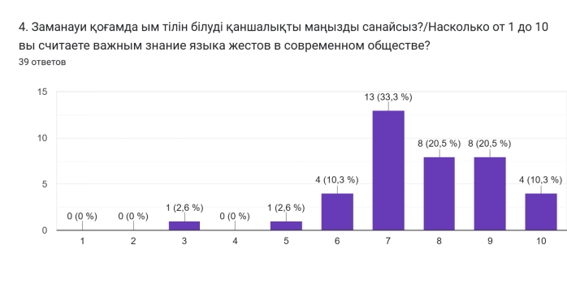
Figure 1. Diagram 1
Diagram 1. On a scale of 1 to 10, how important do you think it is to know sign language in today's society?
Diagram 1 illustrates respondents’ ratings of the importance of knowing sign language in today’s society on a scale from 1 to 10. The results indicate that 33.3% of participants rated the importance as 7, while 20.5% rated it as 8. This concentration around mid-to-high values suggests that respondents generally perceive sign language as moderately to highly important. The absence of extreme ratings further indicates a balanced but positive overall attitude toward the relevance of sign language in modern world.

Analytical Review of Existing Sign Language Learning Tools
To analyze existing approaches to sign language education, several widely used learning tools and games were reviewed and compared with the proposed solution.

Table 1. Comparison of Existing Sign Language Learning Tools
Tool | Platform | Gamification | Gesture Recognition | Levels / Story | Limitations
ASL App | iOS | Limited | No | No | Mostly video-based learning
Play With ASL | Web | Yes | No | No | No real-time gesture feedback
SignTown | Web | Yes | Yes | Yes | Limited availability and language support
Ai-ym | Desktop | Yes | Yes | No | Primarily detects single letters, with limited accuracy.
Proposed Game | Web | Yes | Yes | Yes | Prototype stage.
As shown in Table 1, several digital tools have been developed to support sign language learning. However, they differ significantly in their level of interactivity, feedback mechanisms, and technological sophistication.
The ASL App is a mobile application aimed to teach American Sign Language through video-based demonstrations performed by native signers. The application provides a large vocabulary of signs and common phrases, making it suitable for beginners and self-learners. Even though the use of real human signers enhances visual comprehension and authenticity, the learning process remains largely passive. Users are not able to actively practice gestures within the application or receive feedback on the correctness of their signing, which limits skill development beyond memorization.
Play With ASL a gamified approach to sign language learning by incorporating interactive mini-games such as matching and recognition tasks. This format increases learner engagement and motivation, especially, for children and beginners. However, the application mainly focuses on sign recognition rather than sign production. It does not include gesture recognition or corrective feedback, which reduces its effectiveness in facilitating accurate gesture formation and expressive skills.
SignTown represents a more technologically advanced solution by combining gamification with gesture recognition in a virtual environment. Users can interact with the system by performing signs that are detected through camera-based recognition, allowing for a more immersive learning experience. Despite this innovation, SignTown remains limited in availability and language coverage, as it primarily supports specific sign languages and is often presented as an experimental or research-oriented platform rather than a widely accessible educational application.
AI-Ym. In the context of Kazakh Sign Language, available digital learning tools are even more limited. One notable platform is AI-Ym, a web-based system developed to support the learning and recognition of Kazakh Sign Language. AI-Ym integrates a sign language dictionary with artificial intelligence–based gesture recognition, allowing users to practice signs and receive automated system responses. While this platform represents an important step toward interactive Kazakh Sign Language education, it is primarily available as a web resource and lacks structured, game-based progression and fully developed feedback mechanisms.
Overall, existing sign language learning solutions either rely on passive video instruction, basic gamification, or experimental gesture recognition systems. Fully integrated platforms that combine real-time gesture recognition, structured gameplay, immediate feedback, and broad accessibility, especially for less-resourced sign languages such as Kazakh Sign Language, remain scarce. This gap provides the foundation and justification for the proposed project.

Implementation and analysis
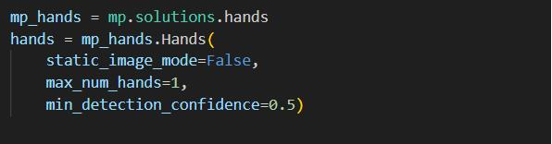
Figure 2. Initialization of the MediaPipe Hands model in tracking model.
By setting static_image_mode=False, the system operates in a continuous tracking mode rather than performing independent detections for each frame. This optimization enhances processing speed and ensures smoother hand landmark tracking, which is essential for real-time gesture recognition.
Figure 3. Extraction of 3D hand landmarks using MediaPipe.
This stage demonstrates one of the core features of MediaPipe: hand landmark extraction. During processing, the model identifies 21 key joints of the hand and outputs their three-dimensional coordinates (x, y, z). The z-coordinate represents the relative depth of each landmark with respect to the wrist, enabling spatial understanding of hand posture. Unlike raw image data, these structured and normalized landmarks provide “clean” input for the AI model, allowing reliable gesture recognition that is largely independent of background complexity and lighting conditions.
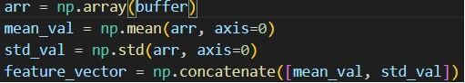
Figure 4. Feature extraction from sequences of 20 hand frames.
In this project, a feature extraction method was implemented to enhance gesture recognition. Rather than analyzing individual frames independently, the system collects a sequence of 20 consecutive frames. For each of the 21 hand landmarks along the X, Y, and Z axes, both the arithmetic mean and standard deviation are calculated. This approach allows the AI model to capture not only the static positions of fingers but also the dynamic movement patterns of gestures, which is critically important for accurate recognition in sign language. By incorporating temporal information, the system improves robustness against minor fluctuations and provides a richer representation of each gesture.
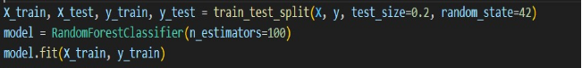
Figure 5. Gesture classification using the Random Forest algorithm.
For gesture classification, the RandomForestClassifier model was selected. This ensemble learning method consists of multiple decision trees, which collectively improve classification accuracy and reduce overfitting. The dataset was divided into training (80%) and testing (20%) subsets to enable objective performance evaluation. This split allows the model to learn gesture patterns from the training data while ensuring reliable assessment of its generalization ability on unseen samples.

Design of the application
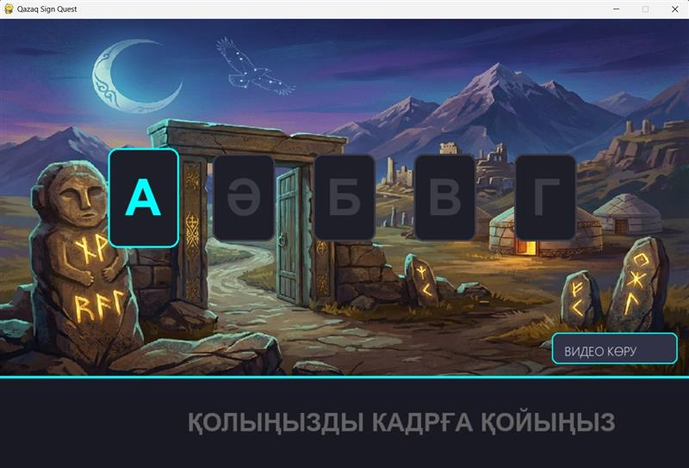
Figure 6. Design of a program
The application features a thematic and intuitive interface designed to bridge cultural heritage with modern technology. The visual style follows a "Quest" concept, utilizing high-quality 2D illustrations of Kazakhstan's landscapes and historical monuments (Balbals).
Functional Components
- Alphabet Selection Panel: A horizontal array of interactive letter cards. The currently selected letter (e.g., "A") is highlighted with a cyan glow effect to provide immediate visual feedback to the user.
- Educational Overlay: A "Watch Video" (Видео көру) action button triggers a tutorial animation, demonstrating the correct finger positioning for the chosen sign.
- Dynamic Guidance System: The bottom footer serves as a real-time instruction hub. It currently displays the prompt "Place your hand in the frame" (ҚОЛЫҢЫЗДЫ КАДРҒА ҚОЙЫҢЫЗ), guiding the user to initiate the AI recognition phase.

Design Philosophy
- Gamification: By placing the learning process within a "Sign Quest" environment, the interface reduces the cognitive load and makes the educational process engaging for younger users.
- Accessibility: High-contrast typography and clear borders ensure that users of various ages can navigate the Kazakh Sign Language (KSL) lessons without difficulty.
- AI-User Synergy: The interface is designed to accommodate a live camera feed overlay (Computer Vision), where the AI model analyzes hand landmarks and provides instant validation of the gesture.

Conclusion:
Through the creation of an interactive educational program, this study offered a gamified AI-based method for learning Kazakh. By combining gesture detection, real-time feedback, and game dynamics, the primary goal of increasing learner engagement and efficacy in comparison to traditional literacy techniques was accomplished. The created prototype shows how cutting-edge digital technology may facilitate inclusive and inspiring sign language instruction.
Accurate recognition of introductory gestures using a conventional camera setup was made possible by the application of MediaPipe Hand Landmarker and machine literacy models. Stoner provocation was appreciatively told by gamification rudiments including scenarios, challenges, and rewards, which were confirmed by test results and prototype testing. The operation enables druggies to laboriously practice motions and admit immediate corrective input, in contrast to being videotape-grounded instruments.
Simultaneously, the design coupled issues pertaining to reliance on tackle quality and recognition delicacy for complex gestures. These issues lay the course for future research, such as growing the gesture collection, refining identification methods, and incorporating immersive technologies like virtual or stoked reality. Overall, the findings show the viability and efficacy of AI-supported game-grounded literacy for teaching sign language.

References
- Lawana, S. P. (2023). Development of a mobile application for interactive sign language learning using AI-powered gesture recognition and gamification. Idea: Future Research. https://idea.ristek.or.id/index.php/idea/article/view/25
- Mukhanov, S., et al. (2025). Gesture recognition of machine learning and convolutional neural network methods for Kazakh Sign Language. Scientific Journal of Astana IT University. https://journal.astanait.edu.kz/index.php/ojs/article/view/398
- Willoughby, L., & Sell, C. (2019). Sign language learning and community inclusion. Journal of Deaf Studies and Deaf Education. https://doi.org/10.1093/deafed/eny024
- Zhassuzak, M., et al. (2025). Enhancing Kazakh Sign Language recognition with BiLSTM using YOLO keypoints and optical flow. Applied Sciences, 15(10), 5685. https://www.mdpi.com/2076-3417/15/10/5685
- Portal FIS TUM. (2025). Virtual reality in sign language education: Opportunities, challenges, and the road ahead. Frontiers in Virtual Reality. https://portal.fis.tum.de/en/publications/virtual-reality-in-sign-language-education-opportunities-challeng
- AI-Ym Project. (n.d.). Explore Kazakh Sign Language education with AI-Ym Retrieved February 6, 2026, from https://www.ai-ym.kz/](https://www.ai-ym.kz/
- Google Developers. (n.d.). MediaPipe solutions for on-device machine learning https://developers.googleblog.com/introducing-mediapipe-solutions-for-on-device-machine-learning/

